**User Interface Design Specification**

**Document Status**: DRAFT

Document Date: 04/01/2015

**Owners:**

Jesse Rafalko

Yiran Mao

Table of Contents

FUNCTIONAL REQUIREMENTS 3

DESIGN PRINCIPLES 3

GUIDELINES 3

Typography 3

Color Themes 4

Icons 4

Taglines 4

OVERALL 5

Design Approach 5

Icons 5

LOG IN PANEL 5

Icons 5

Layout 5

Blueprints 5

PUBLIC WEB PORTAL 5

Design Approach 5

Icons 5

Layout 5

Blueprints 9

CUSTOMER WEB PORTAL 9

Design Approach 9

Icons 9

Layout 9

Blueprints 9

EMPLOYEE WEB PORTAL 9

Design Approach 9

Icons 9

Layout 9

Blueprints 9

CMS WEB PORTAL 9

Design Approach 9

Icons 9

Layout 9

Blueprints 9

# FUNCTIONAL REQUIREMENTS

# DESIGN PRINCIPLES

* Ease of use and information readability
* Responsive, mobile-ready design
* Communicates corporate professionalism
* Takes advantage of leading design trends
* Visual cross-breeding with Tesseract GUI

# GUIDELINES

## Typography

|  |  |  |
| --- | --- | --- |
| Style Tag |  | Options |
| * **Root Font:** * **Header 1:** * **Header 2:** * **Header 3:** * **Header 4:** * **Nav Links** * **Side Nav Links** * **Inline Links** |  | Helvetica Neue 16 px  Orbitron Bold 2.0 rem  Orbitron Medium 1.5 rem  Helvetica Neue Bold 1.5 rem  Helvetica Neue Regular 1.2 rem  Orbitron Black 2.0 rem  Helvetica Neue Bold 1.5 rem  Helvetica Neue Regular 1.0 rem |

## Color Themes

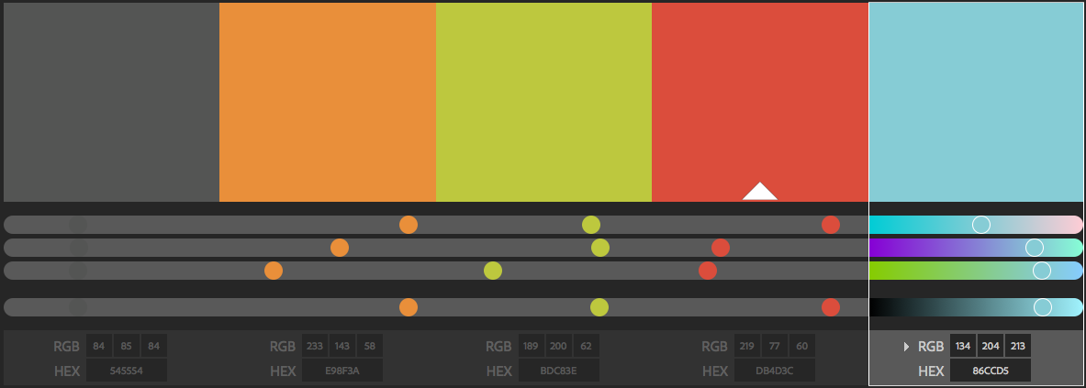

## Icons

|  |  |
| --- | --- |
| * Products | ? |
| * Solutions | ? |
| * Store | ? |
| * Services | ? |
| * Tour | ? |
| * Internationalization | ? |
| * Search | ? |
| * Side Navigation | ? |

## Taglines

* ~~Changing the world one bit at a time~~
* ~~Its not just big data, but all data~~
* Symbolic IO Welcomes you to the storage revolution
* ~~Redefining the world of storage~~
* Tesseract:
  + ** The next dimension of storage
* ~~Moving storage to the next dimension~~
* ~~Making storage follow Moore’s law~~
* ** The *smart* way to store data

# LOG IN PANEL

## Icons

## Layout

## Blueprints

# PUBLIC WEB PORTAL

## Design Approach

## Icons

## Layout

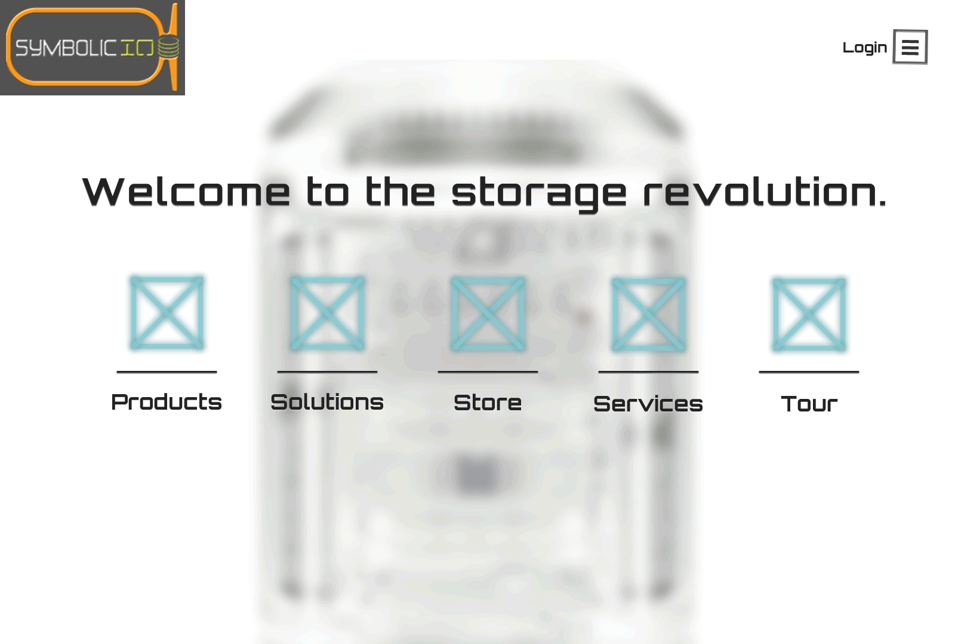

Figure 1: Splash Page

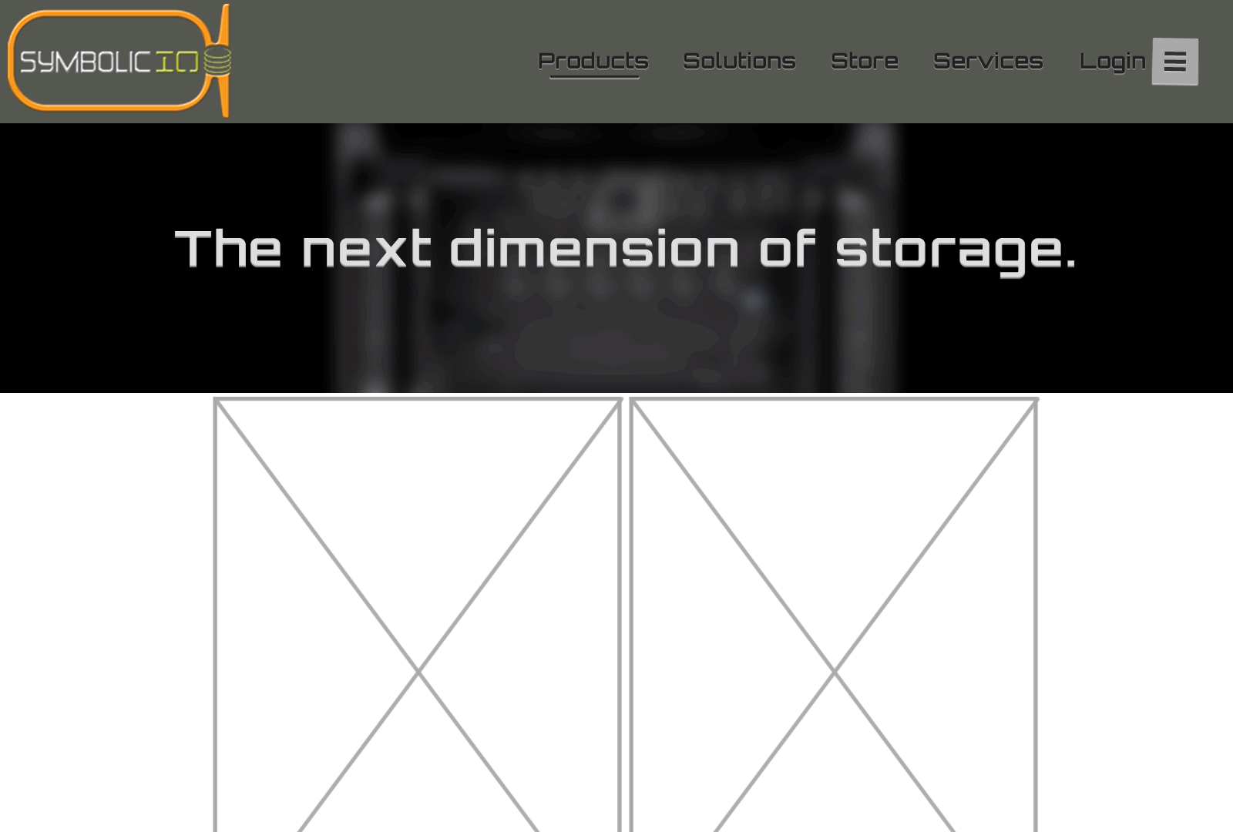

Figure 2: Public Portal

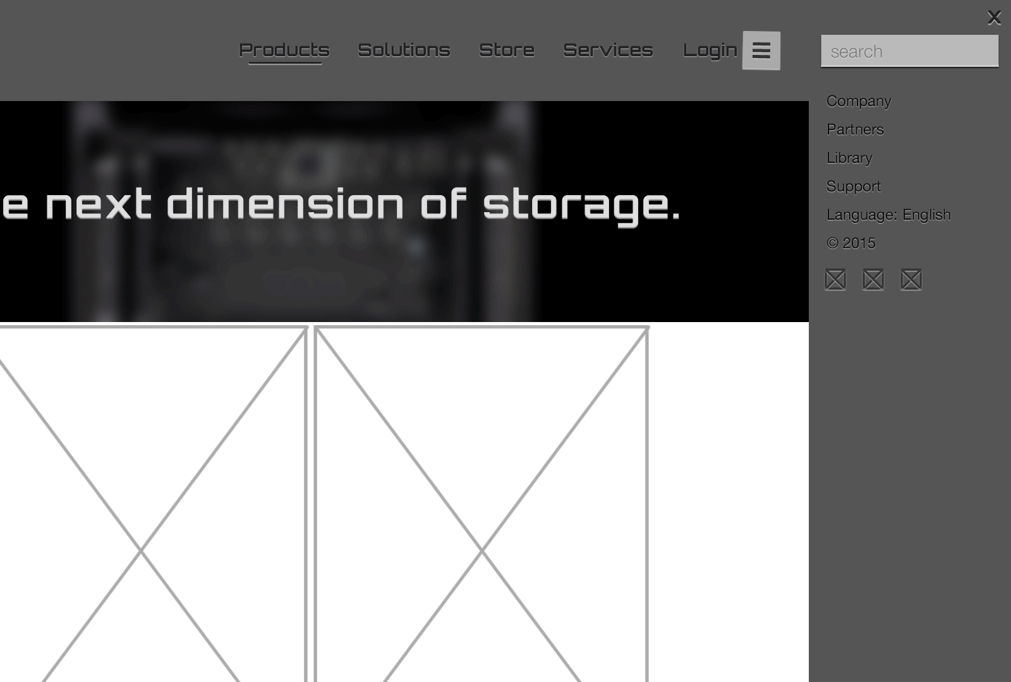

Figure 3: Side Navigation

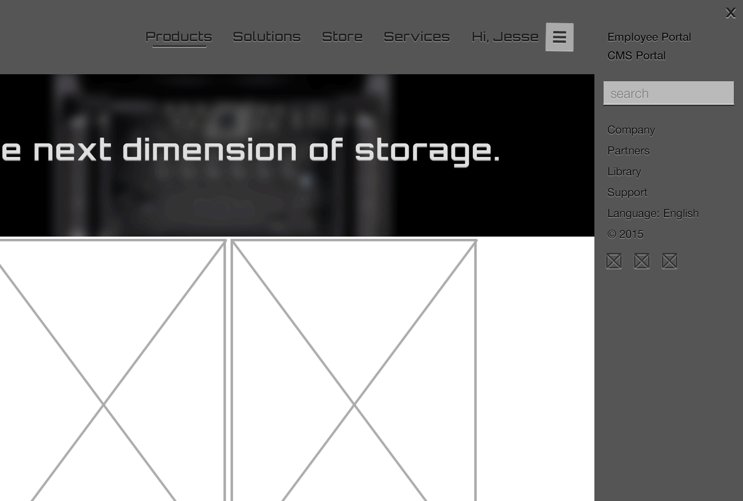

Figure 4: Side Navigation - Logged in

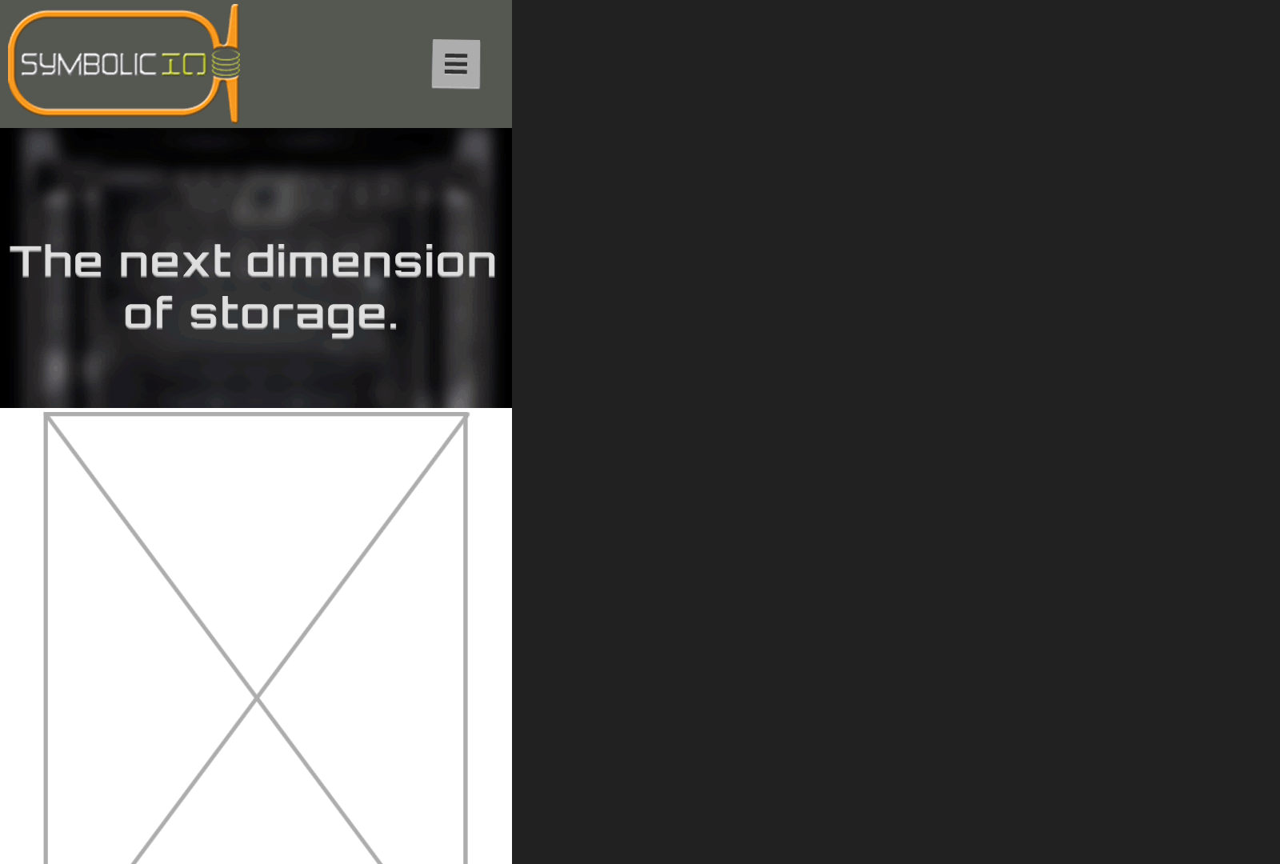

Figure 5: Public Portal - Mobile

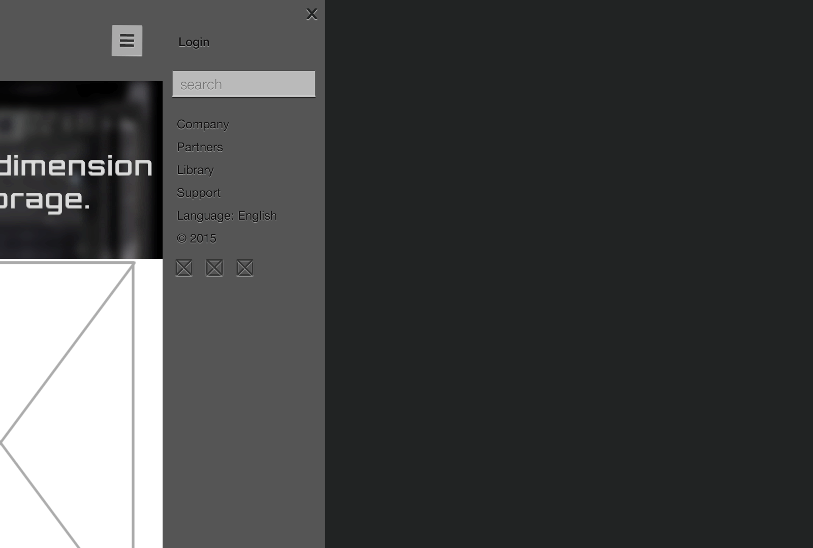

Figure 6: Side Navigation - Mobile

## Blueprints

# CUSTOMER WEB PORTAL

## Design Approach

## Icons

## Layout

## Blueprints

# EMPLOYEE WEB PORTAL

## Design Approach

## Icons

## Layout

## Blueprints

# CMS WEB PORTAL

## Design Approach

## Icons

## Layout

## Blueprints